Command Injection
# Source: AI Source: Provided by: [Data Path: Persons Table -> ID Column: 1, Name_En Column: Motasem Essam] -> From: [ChatGPT] on [1/18/2026]
Command Injection occurs when an attacker is able to inject operating system (OS) commands into a server-side application. These commands are then executed with the same privileges as the application process — which could be root/admin if misconfigured.

🧪 Example
# Source: AI Source: Provided by: [Data Path: Persons Table -> ID Column: 1, Name_En Column: Motasem Essam] -> From: [ChatGPT] on [1/18/2026]
Let’s say your server has code like this (in PHP, Python, Node.js, etc.):
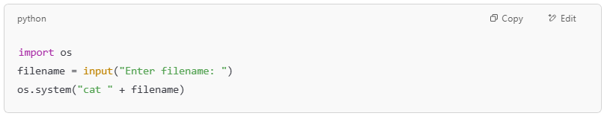
import os
filename = input("Enter filename: ")
os.system("cat " + filename)

If a user enters:
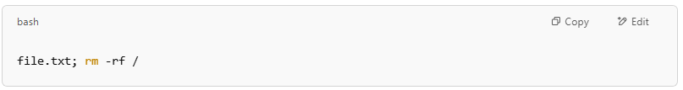
file.txt; rm -rf /

The server runs:
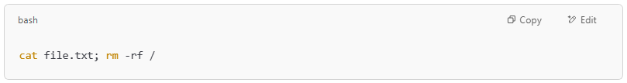
cat file.txt; rm -rf /

🔴 This could delete all files on the server (if permissions allow).

💥 What Attackers Can Do with Command Injection
# Source: AI Source: Provided by: [Data Path: Persons Table -> ID Column: 1, Name_En Column: Motasem Essam] -> From: [ChatGPT] on [1/18/2026]
- Delete or modify files
- Steal sensitive environment variables (like API keys)
- Open reverse shells (remote access to the server)
- Install malware
- Escalate privileges or pivot into other systems

✅ How to Prevent Command Injection
# Source: AI Source: Provided by: [Data Path: Persons Table -> ID Column: 1, Name_En Column: Motasem Essam] -> From: [ChatGPT] on [1/18/2026]

Prevention Method | Description
Avoid using system calls | Don’t use os.system(), exec(), shell_exec(), etc. unless absolutely necessary
Use safe APIs | Use functions that don’t invoke the shell (e.g., Python’s subprocess.run() with args as a list)
Validate input | Only allow known-safe inputs (e.g., filenames with a whitelist of characters)
Use least privilege | Run the application with minimal permissions to reduce damage if exploited
Escape input (as last resort) | If shell execution is unavoidable, properly escape input to remove command injection vectors

🛡️ Real-World Example: Shellshock (CVE-2014-6271)
# Source: AI Source: Provided by: [Data Path: Persons Table -> ID Column: 1, Name_En Column: Motasem Essam] -> From: [ChatGPT] on [1/18/2026]
The Shellshock vulnerability allowed attackers to inject commands into environment variables on servers using Bash. It was widely exploited in web servers using CGI scripts.

🔍 How to Test for Command Injection
# Source: AI Source: Provided by: [Data Path: Persons Table -> ID Column: 1, Name_En Column: Motasem Essam] -> From: [ChatGPT] on [1/18/2026]
Try inputting characters like:
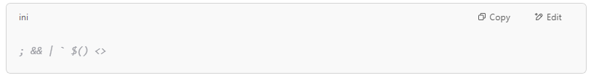
; && | ` $() <>

If the system responds in unexpected ways or executes unexpected commands, it may be vulnerable.

